RAJOURI DISTRICT COLLEGE DATA

- GOVERNMENT DEGREE COLLEGE RAJOURI
- Location:Rajouri, Jammu & Kashmir, India
- Establishment:1981
- Type:Government Institute
General Fee Information:
Average Yearly Fee:Approximately ₹4.11K.
Total Fees Range:From around ₹1.5K to ₹2.5K.

- Accreditation:NAAC accredited
Academics
- Courses:Offers both undergraduate and postgraduate programs.
- Popular degrees:BA, BSc, BCom, and BBA.
- Admissions:Admissions for undergraduate courses (BA, BSc, BCom, BBA) are based solely on merit.
Student Life & Facilities
- Infrastructure:Provides a strong learning environment with a focus on academics.
- Activities:Engages students in extracurricular activities and encourages participation in research and innovation.
- Placements:Offers varied recruitment options for students in both the corporate and public sectors, as well as opportunities for entrepreneurship
IMAGE : https://share.google/images/fiMCXMUuqI2wKvBDv
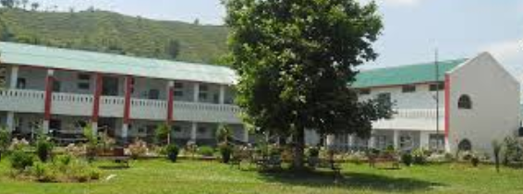

- Government Industrial Training Institute (ITI)
- Location:Shakti Nagar, Jammu
- Establishment:The institute provides training to meet the industry's skilled manpower requirements.
- Affiliation:Affiliated with the National Council for Vocational Training (NCVT) and under the Directorate General of Employment and Training (DGET).
Courses Offered
- Duration:Courses are available in one or two-year durations.
- Types:Offers training in both engineering and non-engineering trades.
Facilities and Infrastructure
- Workshops & Labs:The institute features well-equipped workshops and high-tech computer labs for all trades.
- Classrooms & Library:It has well-ventilated classrooms and a library with a collection of technical and general books.
- Other Amenities:Facilities include recreational areas, a gaming playground, internet connectivity, and medical facilities.
Eligibility
- Candidates must have completed their 10th or 12th grade, with some courses accepting 10th-pass students.
- The minimum age requirement for most ITI courses is 14 years

IMAGE : https://share.google/images/nSSF63ZkC0Vmv4yeH
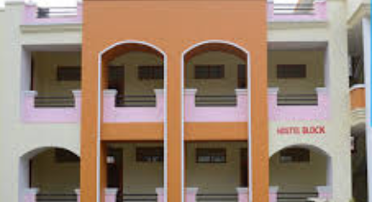

3.Valley View Institute of Education
- Location:Sunderbani, Jammu and Kashmir
- Establishment:2001
- Recognition:NCTE (National Council for Teacher Education)
- Affiliation:State Government university
Courses Offered
The institute offers undergraduate degrees in:
- BA (Bachelor of Arts):Available in subjects like Hindi and Sociology.
- B.Com (Bachelor of Commerce):Focuses on accounting, business management, and other commerce-related fields.
- BCA (Bachelor of Computer Applications):A 3-year program in computer applications.
Admission
- Applicants for most courses are required to have completed 10+2 (Class 12th) with at least 50% marks from a recognized board.
IMAGE : https://share.google/images/Bi0mWf3dmYSIEcEfy
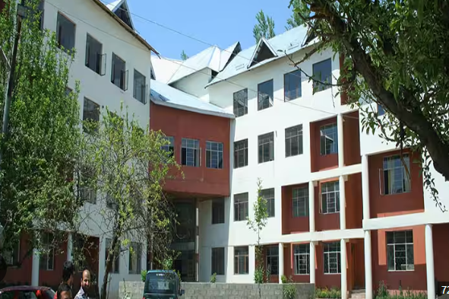

4.GOVERNMENT DEGREE COLLEGE , BUDHAL
- Location:Rajouri district, Jammu & Kashmir, India
- Establishment:May 2008
- Streams Offered:Arts and Science
- Accreditation:NAAC accredited
- Facilities:
  - Spacious smart classrooms
  - Science and computer laboratories
  - Well-stocked library and browsing center
  - NCC and NSS units
  - Sports facilities
  - Wi-Fi enabled campus with a power backup generator
IMAGE: https://share.google/images/eXPZ6x80psEACA9ek
